**DAILY ONLINE ACTIVITIES SUMMARY**

|  |  |  |  |  |  |  |  |
| --- | --- | --- | --- | --- | --- | --- | --- |
| **Date:** | **14/06/2020** | | | | **Name:** | **Churashma** | |
| **Sem & Sec** | **4th SEM 'A' Section** | | | | **USN:** | **4AL18CS019** | |
| **Online Test Summary** | | | | | | | |
| **Subject** | | **No test** | | | | | |
| **Max. Marks** | | **-** | | **Score** | | **-** | |
| **Certification Course Summary** | | | | | | | |
| **Course** | **Introduction to neural networks and deep learning** | | | | | | |
| **Certificate Provider** | | | **greatlearning academy** | **Duration** | | | **9.5 hours** |
| **Coding Challenges** | | | | | | | |
| **Problem statement 1: Write a C program to remove specific characters in the String.** | | | | | | | |
| **Status: completed** | | | | | | | |
| **Uploaded the report in Github** | | | | **yes** | | | |
| **If yes Repository name** | | | | **https://github.com/Churashma/Lockdown-coding** | | | |
| **Uploaded the report in slack** | | | | **yes** | | | |

ONLINE TEST DETAILS: No test

CERTIFICATION COURSE DETAILS: Today I studied about Introduction to tenserflow and also I studied about computational graph.Accelerate the AI/ML capabilities of your team with on-premises expert training. Assess data readiness, empower developers and accelerate your machine learning processing. Best-of-breed open source.A computational graph is a directed graph where the nodes correspond to operations or variables. Variables can feed their value into operations, and operations can feed their output into other operations. This way, every node in the graph defines a function of the variables.

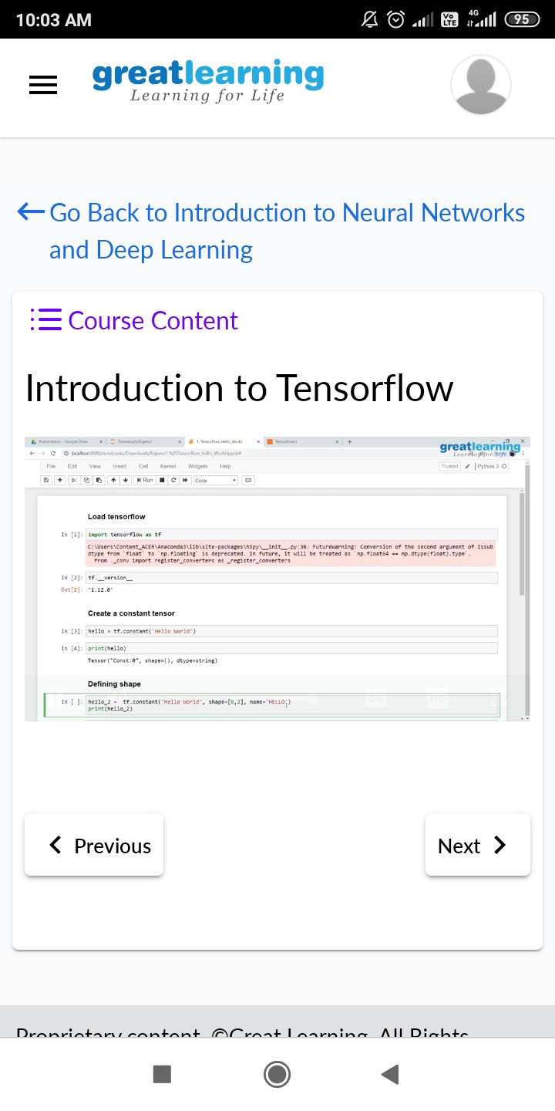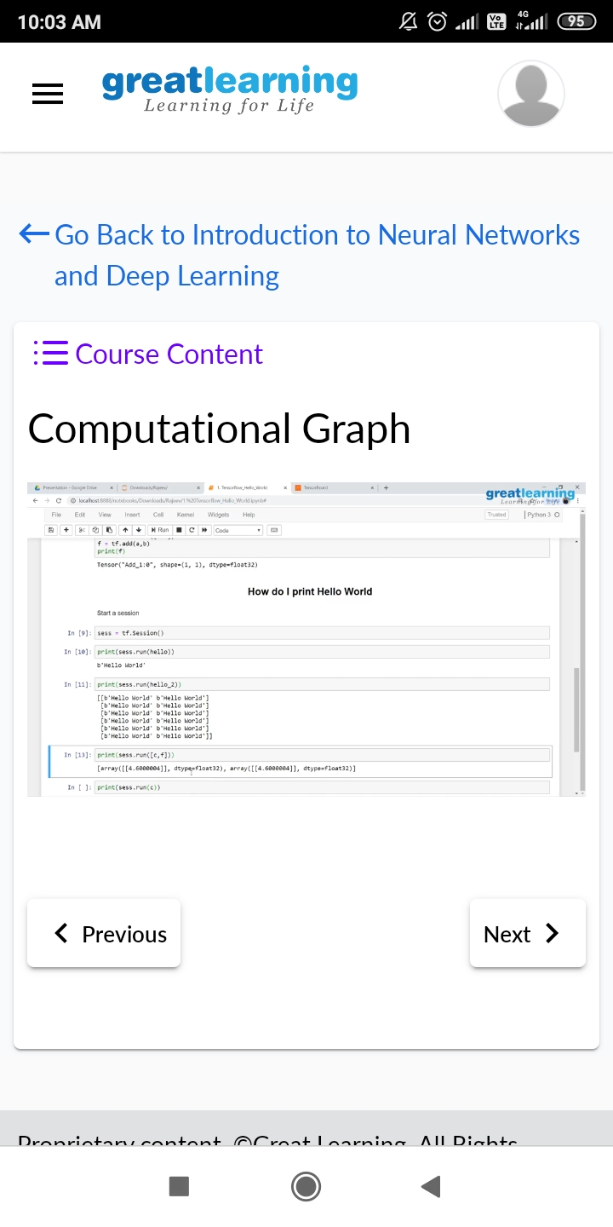

**CODING CHALLENGES DETAILS**:

**Problem statement 1:**  Write a C program to remove specific characters in the String.

